These are the before and after versions of the bitmap and vector designs

Vector

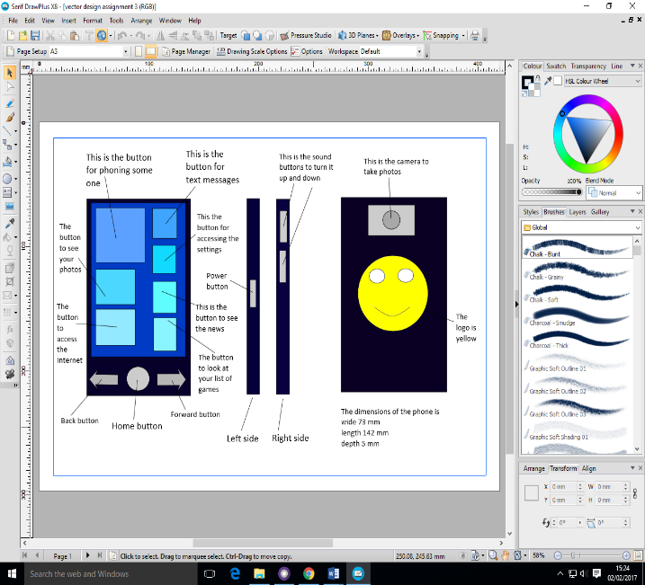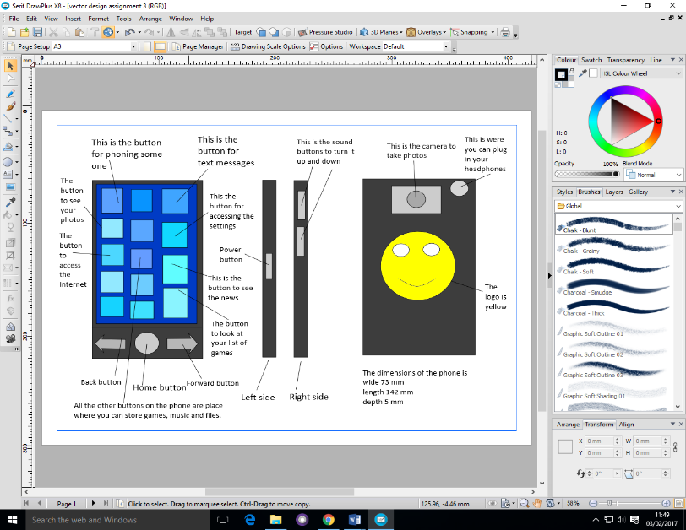Before After

Bitmap

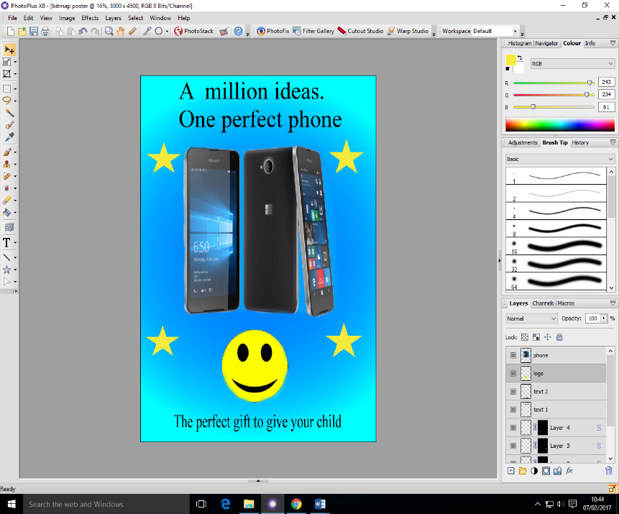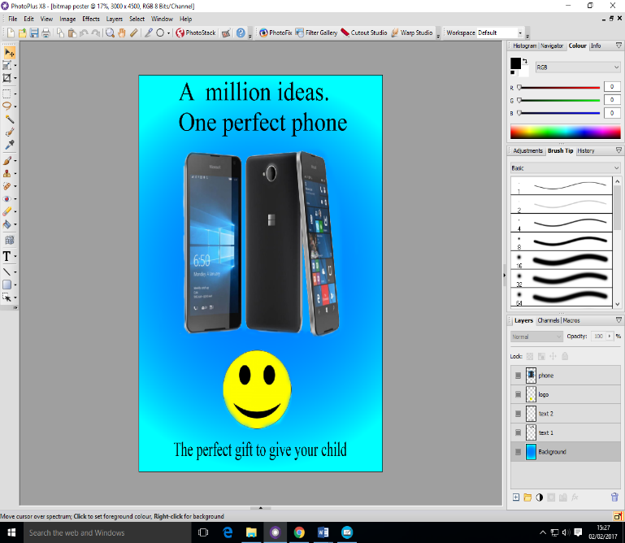Before After

Design justification

The reason that I made these changes to the vector design is because the design needed a place in which the headphones needed to go. This feature is what must phones have and my phone would have been at a disadvantage without because it would make it less appealing to customers because it does not have all the features, which other phones have.

The feedback I got from the design made it clear to me that I have forgotten it and with it in the design it gives the user guide more information and detail, which makes it overall better than the original design. This is because new the design has even more information and features on display then the original had so the original design would have made less money and the audience of the phone would have been smaller the it is now.

Also changing the colours on the phone to a light black made it more suitable to the target audience because the design is less threatening and the black would be too over powering for the eyes and this would make the phone not nice to look at. Having these would have been a bad thing because the design is meant to make the audience want to use the phone and buy it and by have the original designs colours would have been a disadvantage to the phone.

Moreover, the number of buttons was made bigger because it would allow different ways to use the phone. Which would have made different features, which would make some tasks on the phone easier to do and before the improvements there were some features missing from the design which I needed to make the best phone I, could make.

From the feedback, I found the phone would be more suited to a younger audience and I agree with these comments after looking at the phone a second time I think the phone should be market more to younger age’s groups and less on some older age groups, which was my original idea.

The reason that I made these changes to the bitmap design is because having some extra vector images would make the design contain everything that was needed in the brief. This would make the design better for the new target audience, which was outlined in some feedback I got and the new audience is a younger age group.

These images would make it more appealing to the target audience because the children would like to see multiple colours on the design, which would make it more exciting to them and it would make the phone more appealing to the audience making them want to buy it or thinking buy it.

The vector design is more suitable to meet the needs of the target audience because the user guide now shows everything in which it will come with the phone. In addition, it shows where these features are on the phone and the audience will be able to see what the phone will look like once it is available on the market. In addition, the improvements further enhance the design with lots of information included, which would help the interested audience make a choice to buy this model of phone. Also the design phone is suitable for the target audience because I think it is the right size for the people how are going to be using the phone and is shaped in the right way so you can have lots of the screen on display which would help them see things on the phone easier.

The bitmap design is more suitable to meet the needs of the target audience because the design is even further improved and would appeal more to the target audience, which has changed from the original design target audience. The vector images on the design gives it more variety, which appeals to the audience. In addition, the improvements enhance the design to meet all the points in the brief, which makes it the perfect phone in which I can make, and the perfect phone for the target audience.

These are some more improvements that I would make to the designs is that for the vector design should look more to the right size that it well look when it is created and on the market and I wanted to add more apps and features on the phone but I did not know where I would put them on the design so I left them out because I could not fit them in.

These are some improvements that I would make to the bitmap and they would be to make the phone on the design look more like the phone which I designed not a phone which some other person made and I would have added more effects on design put I was limited because I was new to the program and did not know about how to use some features and to get must of the effects working.